**TEDx Talk Cover Page**

**Team Name:** TechBytes 7

**Participating Team Members**

Sharon Olorunniwo

Tin Orešković

Sarah Phillips

Tony Prasad

**Summary Of Presentation**

Our presentation was based on the very controversial and worrying article written by computer scientist Bill Joy. His article painted a picture of a very dystopian and almost apocalyptic future. He supports his arguments and beliefs referencing other credible sources. He advises us to ‘take caution’ advance rapidly in technology. After researching the topic we have come to agree with Joy but not to the same extent. We believe his predictions and assumptions are exaggerated and extreme but they are however not far from our likely future.

**Headshots of Team Members**

  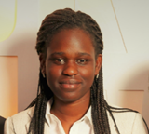 

Tin Orešković Tony Prasad Sharon Olorunniwo Sarah Phillips